**Billing and Collection Layout**

**Current Practices**

Collection efficiency is dependent on the completeness of billing and administrative efficiencies in the collection process. In many ULBs, there is currently no process in place to ensure completeness of billing, timely billing and issuance of payment reminders for payment.

Several ULBs continue to maintain manual records that are vulnerable to errors. Significant staff vacancies in revenue departments also adversely impact collection efficiencies. Some cities that have created an online billing and collection system through procurement of services of an external vendor have difficulties in managing the system due to inadequate capacity building measures being undertaken for revenue officials.

Adoption of online payment of property tax has also been relatively slow and varies across cities. For instance, cities like Pune have more than 55% of the digital/online collections as on XXXX and cities like Raipur and Coimbatore– which also have relatively stronger property tax systems – have much lower rates of adoption of online payment – XX and XX in XXXX year respectively.

A snapshot of current systems is as follows (some good practices are highlighted in green):

Option 1: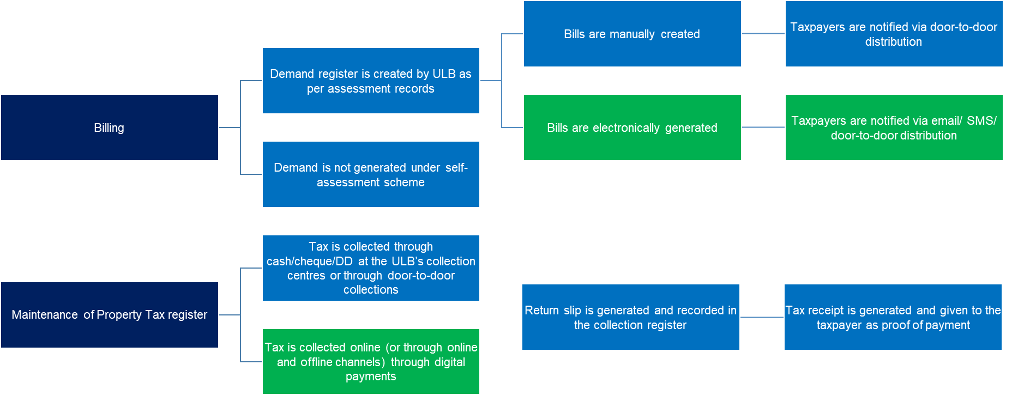

Option 2: 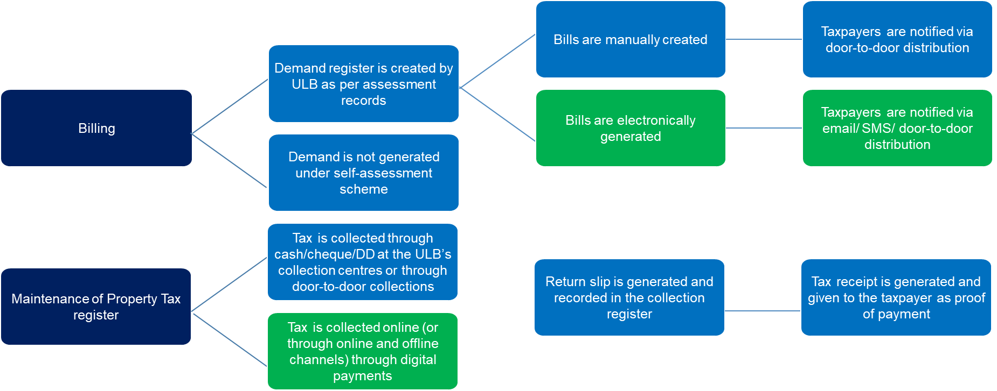

**Recommendations**

The key objective under the Billing and Collection stage is to ensure that ***all assessed properties- properties already under the tax net - are billed,*** the method of billing and collection is ***transparent, easy to administer and enables easy compliance by taxpayers***.

**First Tab:**

**Recommendation 1:**

**Digital billing and online system for collection**

Moving from a manual records system to an online billing and collection system will not only improve transparency and set up an easy to administer process for tax officials but also enable easy compliance by taxpayers. The online system should also ensure that bills are distributed to taxpayers electronically and that automatic payment reminders are sent via SMS/Email.

Andhra Pradesh has been fairly successful in building a centrally run online portal for billing and collection. Delhi’s Municipal Corporations, Greater Chennai Corporation are some examples of states and cities that have successfully migrated to an online system of billing and collection. In 20XX-XX, Tamil Nadu’s Municipal Corporations also migrated to Uniform Tree Information System (UTIS) – an online system of digital billing and collection – which enables online payments for property tax and other user charges and fees that are levied by the Municipal Corporations. Step-by-step process is as follows:

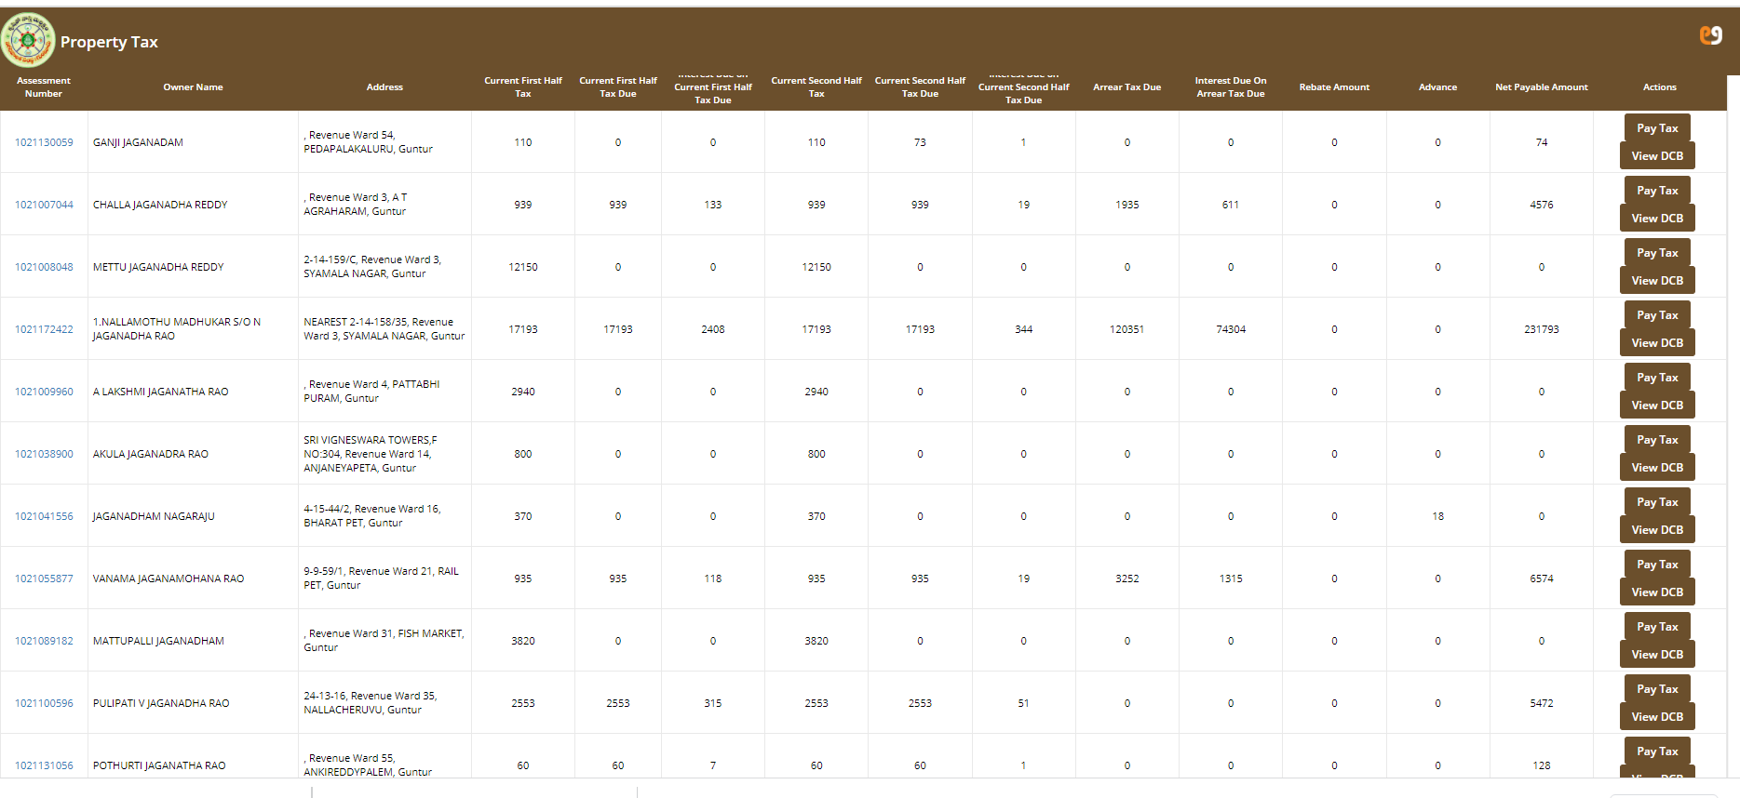

Step One: Digitise manual records and create a Digital Property Tax Register

Step Two: Generate bills against all property tax assessees using an online billing system

Step Three: Notify taxpayers of pending dues through SMS, Email, Door-to-Door Distribution using the online billing system

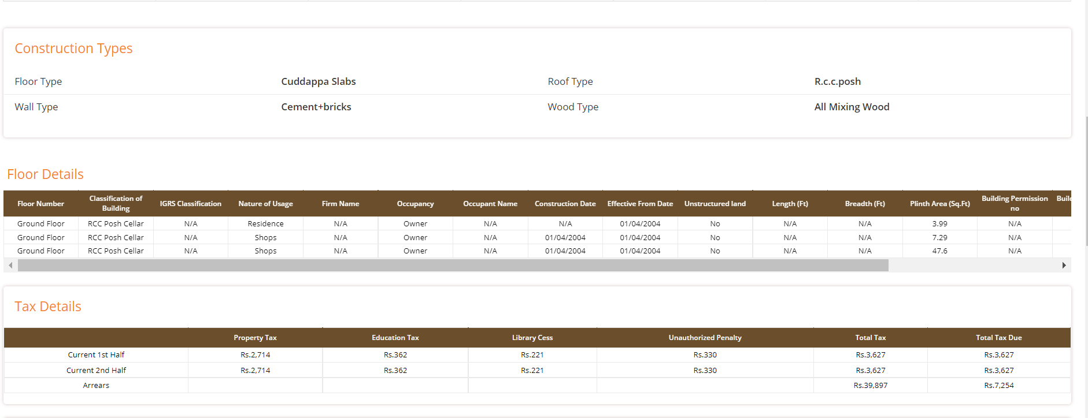

Step Four: Taxpayer logs into the website (or any payment portal integrated with the online system) and pays online through various modes of payment such as Credit/Debit Card/ Net Banking, UPI ID or QR code, Mobile Wallets

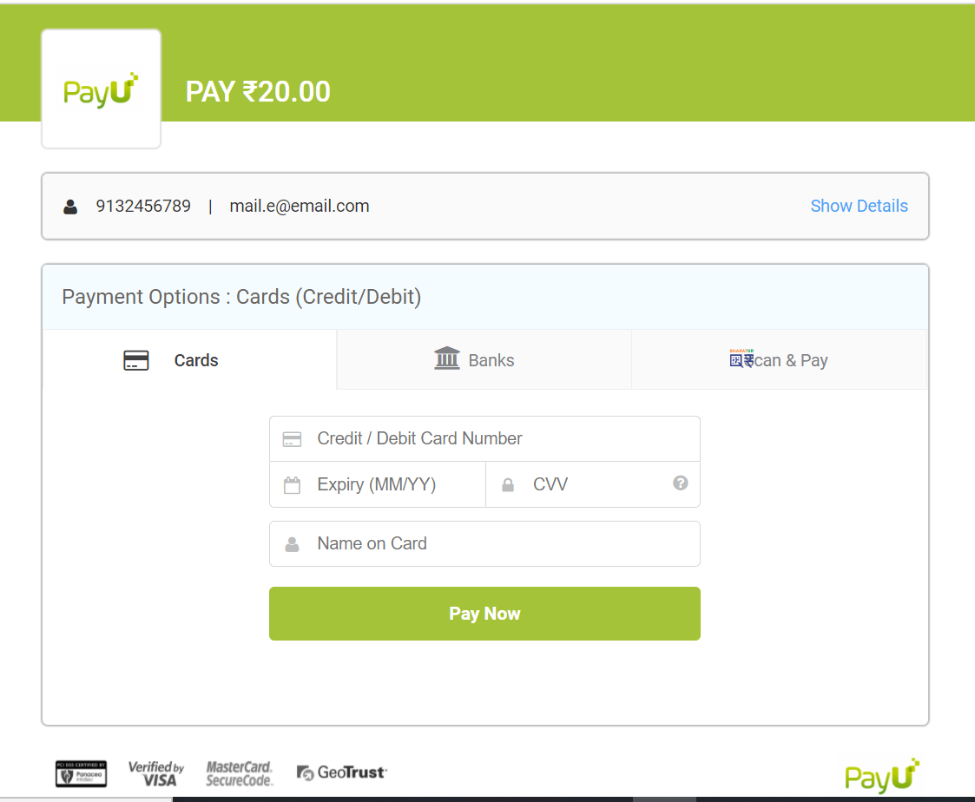

Step Five: Property Tax Records are updated post successful payment and Electronic Receipt is generated

**Image of Electronic Receipt to be inserted**

**Next Tab:**

**Recommendation 2: Technological Interventions**

Following technological interventions coupled with administrative changes can radically improve tax collections–

**Step One: Creation of a *single* digital property register**

The creation of a single digital property register that integrates all Municipal databases and eventually integrates Municipal databases with State Stamp Duties and Registration Records and Electricity Department/Agency’s records is the backbone. This step is discussed in detail under Enumeration (Link)

**Step Two: Integrated or Unified Billing of all Municipal Taxes and Charges**

Every household or commercial property is liable to not only pay property tax but also various other user charges such as water, sewerage, professional taxes (where levied), trade licence fees etc. Having a system of unified billing and collection for every household/commercial property will not only help increase efficiency at the ULB/Agency level by avoiding duplication of efforts for billing and collection, but also reduce the burden of compliance for citizens and establishments by establishing a single relationship with the Local Government.

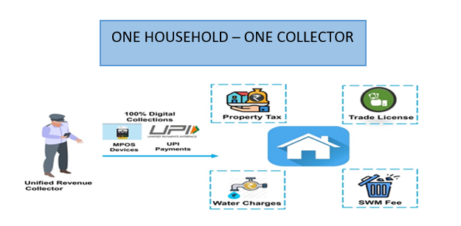

**Step Three: Increase channels and modes of payments**

States/ULBs need to increase both channels (places where taxpayers can pay) and modes (type/options) for payment that are available to taxpayers.

By enabling multiple channels of payment – such as payments through physical centres like ULB’s collection centres, bank branches, door-to-door collections by bill colllectors and by online payments through the state or ULB’s website, through registration at various payment portals like Google Pay, Paytm, Amazon Pay etc.

**Bill Collectors/ Revenue Collectors for Door-to-door collection:** Provide MPOS Devices for enabling all modes of digital payments. Process of payment would be as follows:

**POS Payments:**

Login into POS application on the device

Search the property by ID

Fetch the customer details & select the amount payable

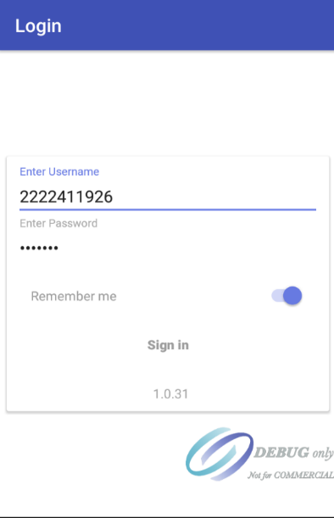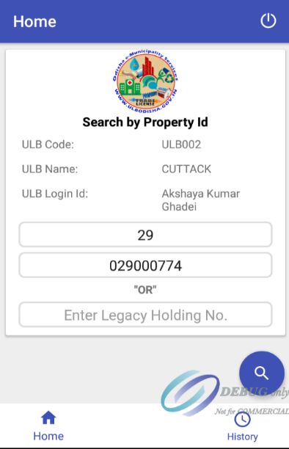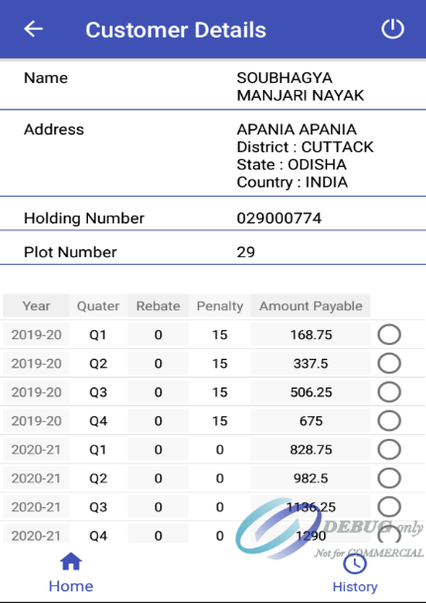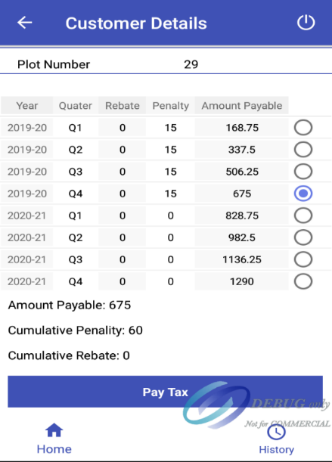

Complete the payment successfully & share the receipt with the tax payer

Choose the mode of payment for collection depending on tax payer’s preference

Enter the amount to be collected & mobile number details of the tax payer

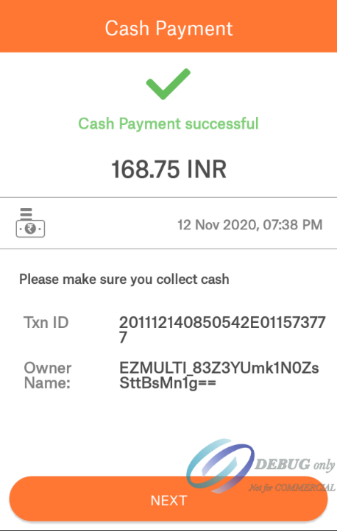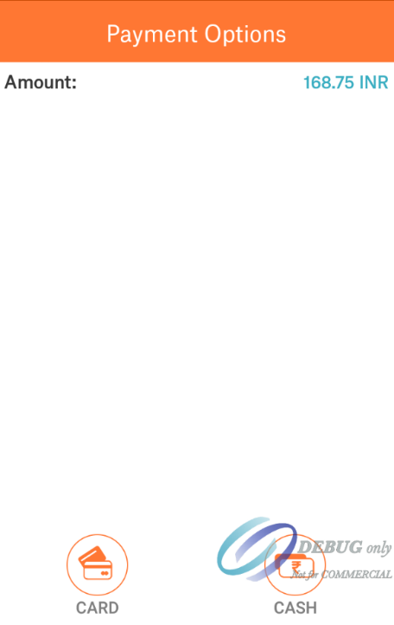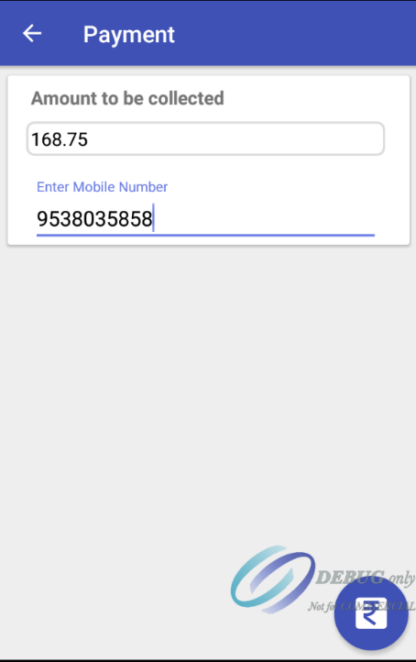

After creating the necessary infrastructure for digital payments by increasing both modes and channels of digital payment, ULBs can also explore sending Payment Link Reminders through SMS/Whatsapp/Email for augmenting digital payments and reducing the reliance on cash/cheque/DD collections and dependence on physical collection centre.

**Payment Link Reminders (Graphic for description of entire process):**

Taxpayers should get alerts via SMS/Whatsapp/Email about pending dues. After clicking on the link, the taxpayer is directed straight to the payment gateway which displays the pending tax. Post payment, an online receipt is generated.

Bulk SMS/email/Whatsapp services are provided by various providers of cloud such as Fast2SMS, SMSRoot, Kaleyra, Exotel, SMSGateway, etc. The pricing of these services depends on the scale of bulk SMSes procured. Indicative costing ranges from 9p/sms plus taxes (with a scale of 5 lakh+ smses) to 18p/sms plus taxes. The strategy can be used in a targeted fashion by focusing on taxpayers that have the highest arrears, have not paid their dues over 6 months etc.

**Payment Links to be shared via SMS or WhatsApp with taxpayers**

**After clicking on the link, the taxpayer will be directed to payment gateway on the website where pending demand to be paid will be displayed**

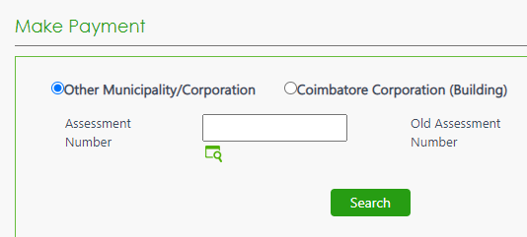

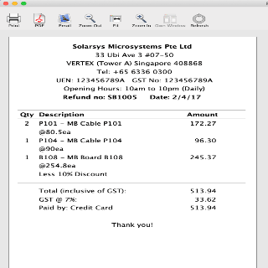

**Post payment, an online receipt will be generated which can be saved for future records**

**Step 5: De-link the functions of assessment and billing and collections**

There is a strong case to delink assessment and billing and collections both from the perspective of internal controls (segregation of duties) but also from the perspective of outsourcing and specialisation. A unified cadre of collectors who focus on collections from specific categories of properties (residential, commercial, high value), or different categories of taxpayers (defaulters, and within that hard, soft buckets etc.) or geographies (by ward, by ULB) and who are enabled by MPOS with a map and timetabling can deliver transformative results in collections (adapting Uber, Swiggy models to collection function) and also drive operational efficiencies within ULBs at a broader level.

The success story of Ranchi Municipal Corporation (summarized in Box 4 below), where there was a fourfold increase in collections between FY 14-15 and FY 17-18 post outsourcing of collection, merits serious evaluation for adoption. Several cities like Ludhiana and Amritsar have tackled the issue of staff deficit by outsourcing collection centres. They have created Citizen Facility Centers (CFC) in zonal offices responsible for filling the assessment forms of all walk-in taxpayers and collecting taxes through cash, online and digital channels.

**Next Tab:**

**Recommendation 3: Stronger penal provisions for defaulters**

Enabling penal provisions in State/City Acts for defaulters will strengthen the hands of revenue officials in ensuring compliance by assessees. These provisions should also be combined with dissemination of defaulters’ list in public domain, for instance, at the ULB’s offices, collection centres, website, etc. and through the communication to the defaulter via demand notices.

For instance, as per the XXXX amendment to the Chennai City Municipal Corporation Act, 1919, assesses who pay advance property tax, i.e. before October 15 of each year will be given a 5% incentive (upto a maximum of Rs. 5,000/-) and payments made after October 15 of each year will attract a penalty of 2% p.a. This amendment has led to Rs. xxxx crore collections in XX year (XX% increase) as compared to XX year.

Early bird discounts and late payment penalties have also shown positive results in Pune, Hyderabad and Delhi’s Municipal Corporations by boosting early payments by taxpayers which consequently has helped improve availability of cash flows throughout the year.

International examples also showcase that a strong emphasis on improving administrative processes leads to an uptake in collections. For example, in Quezon City, Philippines, the Local Government Code provides for various enforcement provisions including seizure and auctioning of delinquent properties. To boost revenue collections, the Local Government has adopted a system of implementing enforcement provisions coupled with an incentives mechanism for taxpayers- discounts for early payment and penalties for late payment which led to more timely payments.

Best Practices (PDFs):

1. Heading: Unified billing of property tax and other charges in Andhra Pradesh
   1. Description: Andhra Pradesh has implemented a system of unifie billing of property taxes, water and sewerage charges and also transformed its collection systems by introducing multiple modes and channels of payments for taxpayers **(Description may change, but characters will be within the current character limit)**
2. Heading: Easing Property Tax collection process using Mobile Point of Sale (MPOS) devices in Odisha
   1. Description: Through the introduction of MPOS devices- which operate as integrated payment solutions through data-pull from the existing property tax register- ULBs across Odisha have been able to increase human resources efficiencies by eliminating time spent on manual input, validation and verification of collection entries through the digitisation of property tax collections.
3. Heading: Unified revenue collection of property tax and user charges: A Pilot in Puri, Odisha
   1. Description: Since November, 2021, a pilot project is being run in Puri, Odisha for unified revenue collections of property tax and water charges, i.e. ‘One Household- One Collector’, to optimally utilise existing human resources, increase household-wise coverage and enhance revenue collections **(Description may change, but characters will be within the current limit)**